Unlocking Data Transformation: My journey with dbt (Data Build Tool) on SQL Server
I would like to share my experience with SQL Server, and we have spent years fighting with SSIS packages, stored procedures, and endless ETL scripts you know how tough it is to keep data pipelines clean and easy to work with. From last one year I have been doing research on dbt (data build tool), and honestly, it's changed everything and my perception. Using it with SQL Server through the dbt-sqlserver adapter has made my work so much smoother, and I didn't even have to leave my favorite database.
In this article, I am going to show you how I got dbt working on SQL Server. We'll cover the basics, go through the setup, build a simple project, and I'll share some problems I ran into along the way (this is most of the time I have spent to setting the environment) at the end I have shared all the issues. As a data engineer tired of messy scripts or a DBA who wants to try modern tools, this should help you get started. My takeaway from using dbt is that it made me feel like a real programmer while working on data engineering projects. I had the kind of support I usually see in software development like a clear project structure, built-in testing, documentation, lineage tracking, and, most importantly, strong data-quality checks.
Why I Chose dbt for SQL Server
dbt isn't just another ETL tool. It's a transformation layer that lets you write SQL models in pieces, test them, document them, and schedule them all in a version-controlled repo. Think of it like Git for your data warehouse code, with built-in tracking of how everything connects.
For us SQL Server folks, here's why it's great:
- You already know this stuff: Just write T-SQL queries as dbt models. No weird new language to learn.
- Break things into smaller pieces: Turn huge transforms into parts you can reuse.
- Testing is built right in: Catch mistakes early with tests you can write yourself.
- Works with other tools: Connects easily to things like Airflow or dbt Cloud.
I used this to fix a messy reporting pipeline at my last job. Cut deployment time in half and made code reviews way easier. If you're running Azure SQL or on-prem SQL Server 2019 or newer, you're good to go.

What You Need Before Starting
Let me tell you what you'll need first. I'm assuming you're on Windows (dbt works great there), but Mac or Linux users can make it work with Docker.

- SQL Server: Version 2016 or later. I tested mine on 2022 with the latest updates. Make sure TCP/IP is turned on in SQL Server Configuration Manager and write down your instance name and port.
- Python: Version 3.8 to 3.11. Get it from python.org. Don't use 3.12 or 3.13 dbt stopped supporting them and I learned that the hard way. (Here I have to un install latest python version and kept only 3.11)
- Git: For version control.
- A database: Make a new schema for dbt models, something like dbt_demo. Give your user db_datawriter and db_ddladmin permissions.
Quick tip: If you're on Azure SQL Database, the hyperscale tier handles bigger models better because of how it deals with parallel processing.

Following all steps I did in Power shell
Step 1: Installing dbt and the SQL Server Adapter
python -m venv dbt_env
dbt_env\Scripts\activate
let’s install dbt-core and the adapter:
pip install dbt-core dbt-sqlserver
while executing the above step you may need following software’s based on your windows configuration.
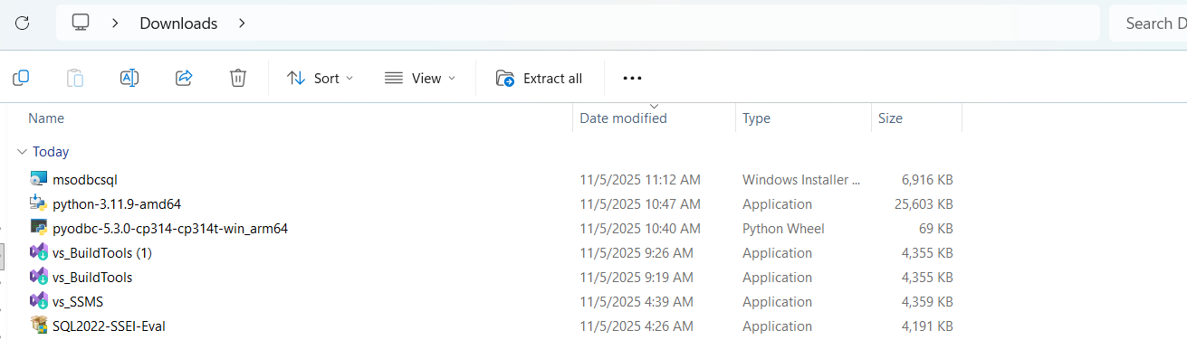
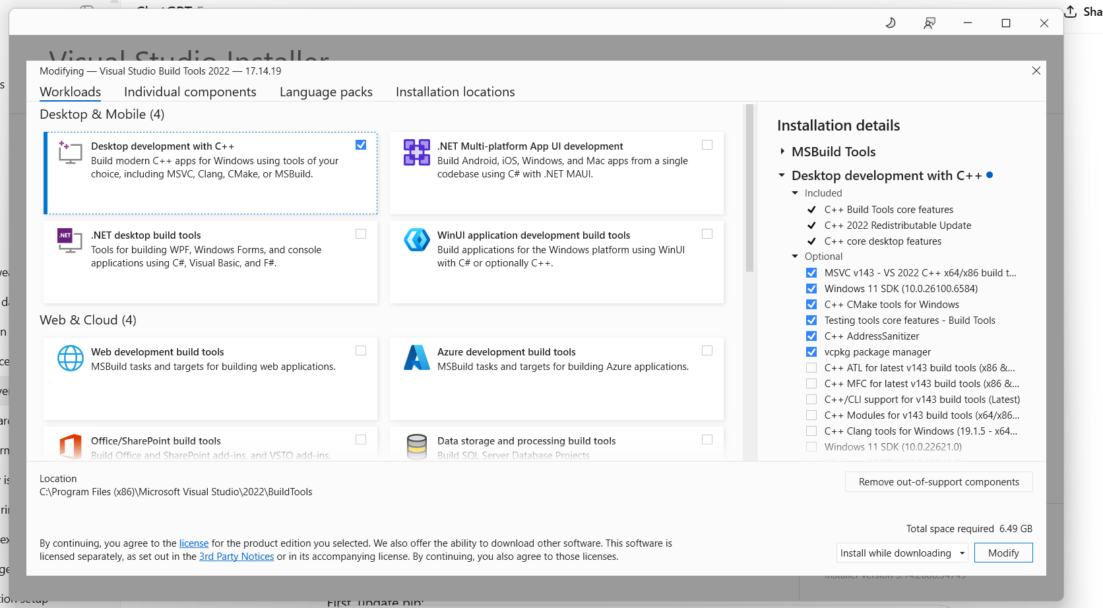

dbt –version
You should see something like below.
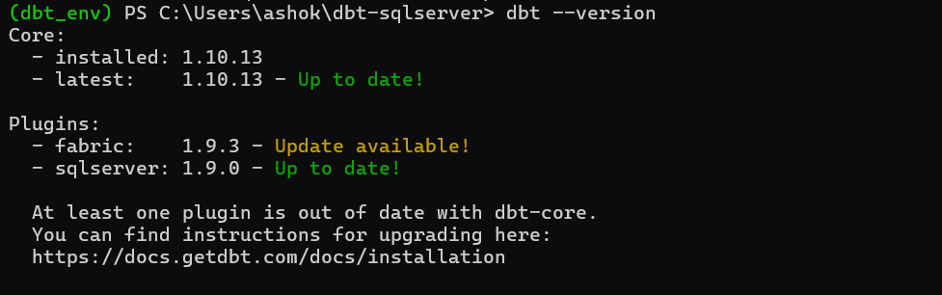

Step 2: Setting Up Your dbt Profile
dbt uses a file called profiles.yml to connect to your database. Make this file at ~/.dbt/profiles.yml (on Windows that's C:\Users\YourName.dbt\profiles.yml).
Here's what I use for my local SQL Server:

demo_profile:
target: dev
outputs:
dev:
type: sqlserver
driver: "ODBC Driver 18 for SQL Server"
server: "127.0.0.1,1433" # TCP direct – bypasses instance resolution
database: Sales
schema: dbt_demo
user: sa
password: MyStrong@123
port: 1433
encrypt: false
trust_server_certificate: true
threads: 4

Test if it connects:
dbt debug

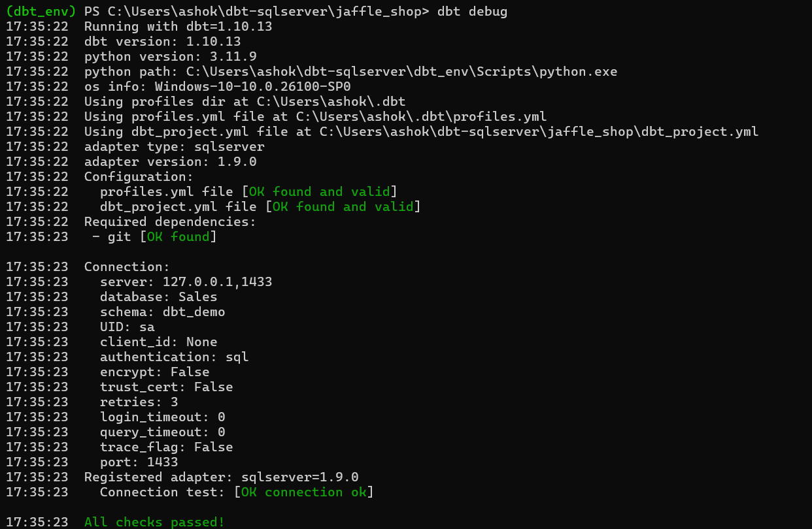

Green checkmarks? You're connected. Red errors? Check your ODBC drivers or firewall settings. I once wasted an hour on a timeout error that was just a blocked port.

Step 3: Creating Your First dbt Project
dbt init my_sqlserver_project
cd my_sqlserver_project

This creates a bunch of folders: models/, macros/, tests/, and more. Open up dbt_project.yml and point it to your profile:

name: 'my_sqlserver_project'
version: '1.0.0'
# This setting configures which "profile" dbt uses for this project.
profile: 'demo_profile'
# These configurations specify where dbt should look for different types of files.
# The `model-paths` config, for example, states that models in this project can be
# found in the "models/" directory. You probably won't need to change these!
model-paths: ["models"]
analysis-paths: ["analyses"]
test-paths: ["tests"]
seed-paths: ["seeds"]
macro-paths: ["macros"]
snapshot-paths: ["snapshots"]

clean-targets: # directories to be removed by `dbt clean`
- "target"
- "dbt_packages"

# Configuring models
# Full documentation: https://docs.getdbt.com/docs/configuring-models

# In this example config, we tell dbt to build all models in the example/
# directory as views. These settings can be overridden in the individual model
# files using the `{{ config(...) }}` macro.
models:
my_sqlserver_project:
staging:
+materialized: view
marts:
+materialized: table

Let's add some test data. Put a CSV file in seeds/ folder raw_customers.csv:
id,name,email
1,Ashok Gadiparthi,ashok.gadiparthi@example.com
2,Jane Smith,jane@example.com

Run dbt seed and it loads this as a table in your database.
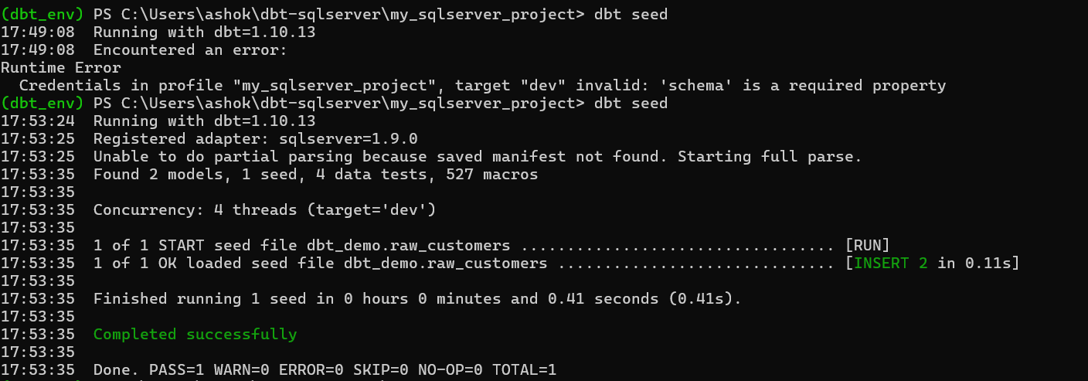
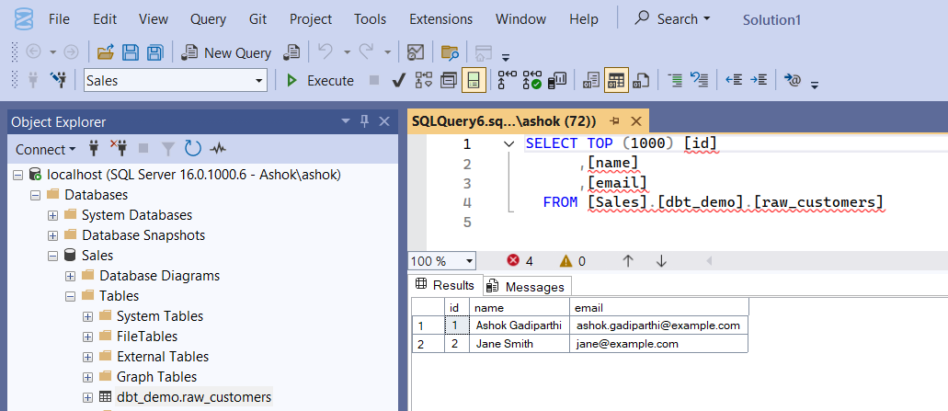

Step 4: Building and Running Your Models
This is where dbt really shines. Make a file called models/staging/stg_customers.sql:
{{ config(materialized='view') }}
select
id,
name,
email,
current_timestamp as loaded_at
from {{ ref('raw_customers') }}
where email is not null

That {{ ref() }} thing is cool it handles dependencies automatically. dbt figures out what order to run things.
Now make another model in models/marts/dim_customers.sql:

{{ config(materialized='table') }}
with cleaned as (
select
id,
trim(name) as customer_name,
lower(email) as email
from {{ ref('stg_customers') }}
)
select * from cleaned

Run everything:
dbt run
dbt compiles it all, runs it, and logs what happened. Check your database schema you'll see stg_customers as a view and dim_customers as a table. Pretty cool, right?
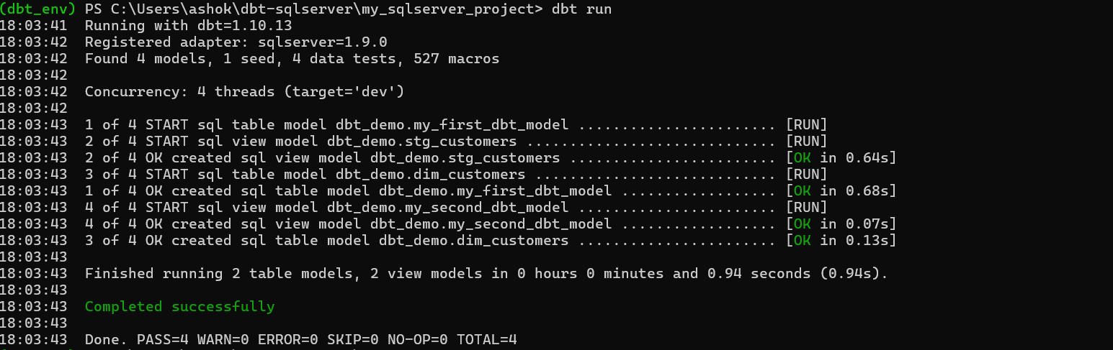
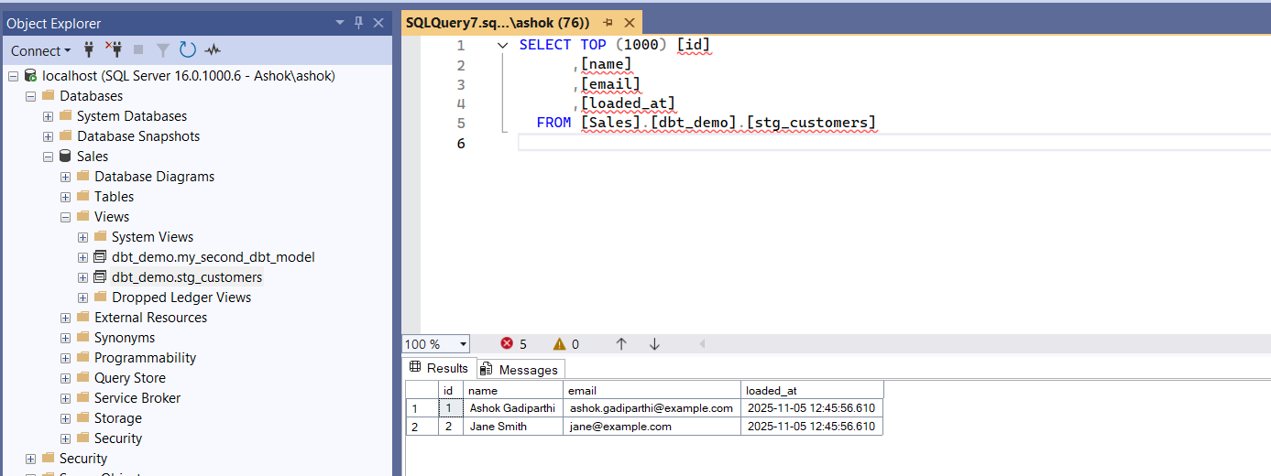

Following step is optional, because I am planning to create separate article for incremental usecase, for bigger datasets where you only want to load new stuff (incremental loads), do this:

{{ config( materialized='incremental', unique_key='id' ) }}
select * from {{ ref('stg_customers') }}
{% if is_incremental() %} where loaded_at > (select max(loaded_at) from {{ this }}) {% endif %}

Then run dbt run --models dim_customers to try it out.

Step 5: Testing and Documentation
version: 2
models:
- name: stg_customers
columns:
- name: id
tests:
- not_null
- unique
- name: email
tests:
- accepted_values:
arguments:
values: ['example.com', 'test.com']

- name: raw_customers
columns:
- name: customer_name
tests:
- dbt_utils.expression_is_true:
expression: "customer_name IS NOT NULL AND customer_name <> ''"

Run dbt test and it'll catch problems before they hit production. For documentation, run dbt docs generate and then dbt docs serve. It opens this really nice web page with diagrams showing how everything connects.
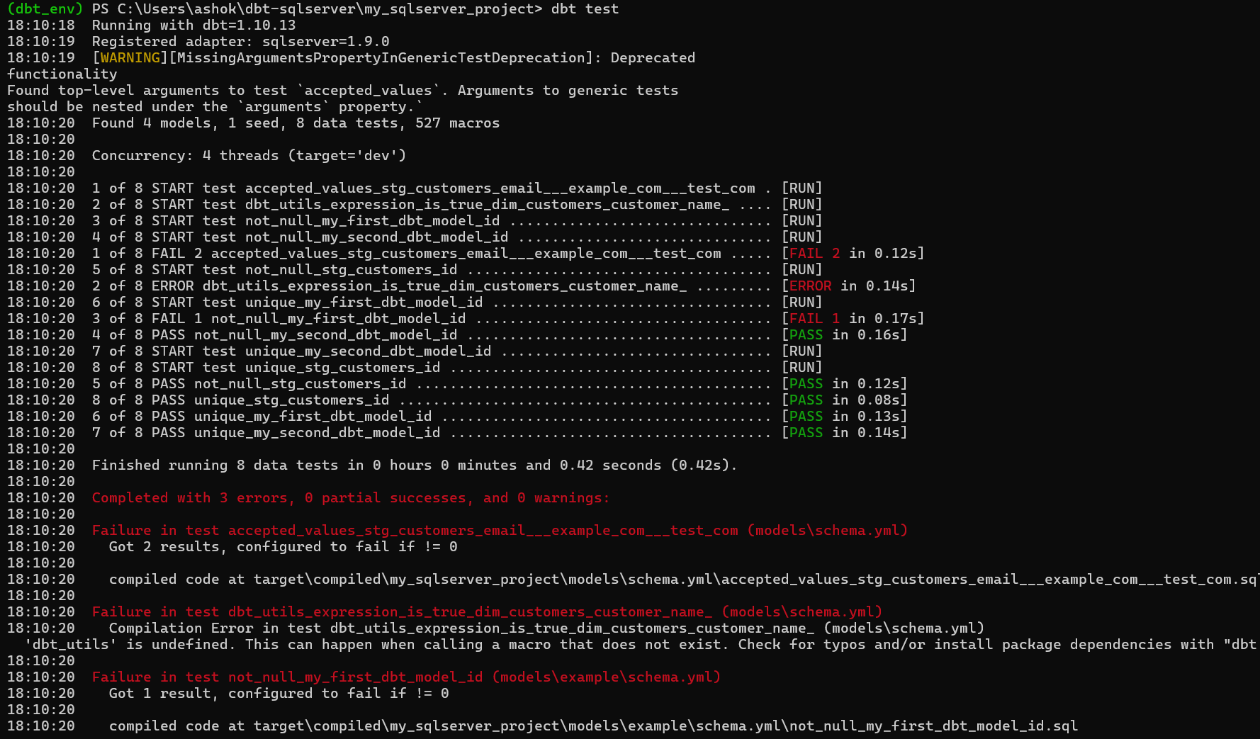

Problems I Ran Into (And How I Fixed Them)
Here are some things that tripped me up:
- ODBC Connection Problems: If your connection keeps dropping, make sure your profile is set up right. For Windows authentication, use trusted_connection: true.
- Collation Issues: SQL Server's case-sensitive settings can cause weird errors. I set collation: SQL_Latin1_General_CP1_CI_AS in my model configs.
- Speed Issues: For big runs, increase threads but keep an eye on tempdb. I don't use dbt run --full-refresh very often because it's slow.
- Working with Teams: Put your adapter versions in a requirements.txt file so everyone's using the same setup.
- Azure Synapse: If you're using Synapse or Fabric, the serverless pools make testing really fast.
Want to schedule stuff? Try dbt Cloud the free version works great for solo projects.

Common Windows Setup Pitfalls and Fixes
Since this is aimed at folks starting from scratch on Windows, I’ll share some notes from my own headaches during setup. These aren’t in the official docs, but they’re the stuff that ate up hours for me. If you hit these, you’ll save time.
- Python Version Mismatch: Don’t use Python 3.12 or 3.13 pyodbc (which dbt-sqlserver needs) doesn’t have pre-built wheels for them yet. Stick with 3.11. If you already have a newer version, install 3.11 alongside and use py -3.11 -m venv dbt_env to create your virtual environment. After, activate with .\dbt_env\Scripts\Activate.ps1 (in PowerShell).
- PowerShell Script Execution Policy: When activating your venv with .\dbt_env\Scripts\Activate.ps1, you might get a security error. Fix it temporarily with Set-ExecutionPolicy -Scope Process -ExecutionPolicy Bypass. For a permanent fix, run as admin: Set-ExecutionPolicy -ExecutionPolicy RemoteSigned -Scope CurrentUser.
- Upgrading Pip with Spaces in Path: If your Python is in "C:\Program Files", wrap the path in quotes: & "C:\Program Files\Python311\python.exe" -m pip install --upgrade pip. Otherwise, it thinks "C:\Program" is a command.
- Avoiding dbt-fusion: If dbt --version shows "dbt-fusion" instead of dbt-core, you've got the preview version, which doesn't support SQL Server or dbt init with arguments. Uninstall with pip uninstall -y dbt-fusion dbt-core dbt-sqlserver, then reinstall pinned: pip install "dbt-core==1.9.0" "dbt-sqlserver==1.9.0". If it's stubborn, delete your venv and recreate it fresh.
- Pyodbc Compilation Fails: If you see "Microsoft Visual C++ 14.0 or greater is required", grab a pre-built wheel from https://www.lfd.uci.edu/~gohlke/pythonlibs/#pyodbc (e.g., pyodbc-5.1.0-cp311-cp311-win_amd64.whl for Python 3.11). Install with pip install path\to\your\wheel.whl, then retry dbt-sqlserver.
- SQL Server Connection Hangs or "Instance Not Found": Enable TCP/IP in SQL Server Configuration Manager (under Network Configuration > Protocols for SQLEXPRESS). Set port 1433 in IPAll. Start SQL Server Browser service. Test with Test-NetConnection -ComputerName localhost -Port 1433. Use server: "127.0.0.1,1433" in profiles.yml to bypass name resolution.
- SA Login Disabled by Default: No default password. In SSMS (Windows Auth), run: ALTER LOGIN sa ENABLE; ALTER LOGIN sa WITH PASSWORD = 'MyStrong@123';. Restart service. Use encrypt: false and trust_server_certificate: true for local.
- "Cannot Generate SSPI Context": Switch to SQL auth (sa), or force trusted_connection: yes in extra:. For Windows auth, set encrypt: false.
- Wrong Directory for dbt Commands: Run dbt debug or dbt run inside your project folder (e.g., cd jaffle_shop), not the venv root. Look for dbt_project.yml as a clue you're in the right spot.
- Creating Database/Schema: In SSMS: CREATE DATABASE Sales; GO. Then: USE Sales; CREATE SCHEMA dbt_demo; GO. Grant permissions: GRANT CREATE TABLE, INSERT, SELECT, ALTER ON SCHEMA::dbt_demo TO [your_user];.

