Integrating Python with MongoDB

Introduction
MongoDB has gained significant popularity as a NoSQL database solution due to its flexibility, scalability, and document-oriented nature. Python, on the other hand, is a versatile programming language known for its ease of use and rich ecosystem of libraries. This article explores the integration of Python with MongoDB, covering fundamental concepts with practical implementation steps using “pymongo” library. The integration of these two technologies provides developers with a powerful toolset for building modern and efficient applications.

Overview of MongoDB
MongoDB is a popular NoSQL database that offers a flexible, document-oriented approach to data storage. Unlike traditional relational databases, which store data in tables, MongoDB stores data in collections of JSON-like documents. This allows developers to store and retrieve complex, unstructured, or semi-structured data more efficiently. Some of the key features of MongoDB are:
Document-Oriented: MongoDB stores data in documents, which are self-contained units that can hold various types of data without requiring a fixed schema.
Scalability: MongoDB supports horizontal scaling by distributing data across multiple servers, making it suitable for handling large datasets and high traffic.
Flexibility: The dynamic schema of MongoDB enables changes to the data structure without affecting existing records, making it adaptable to evolving application needs.
Indexes: MongoDB supports various index types, enabling efficient data retrieval and improving query performance.
Query Language: MongoDB's query language allows you to filter, sort, and transform data using JSON-like queries.
Aggregation Framework: The aggregation framework provides powerful tools for data transformation, analysis, and reporting.
Geospatial Capabilities: MongoDB offers geospatial indexing and querying to handle location-based data.
Replication and High Availability: MongoDB supports replica sets to provide data redundancy and automatic failover in case of server failures.
Security: MongoDB offers authentication, authorization, and role-based access control to ensure data security.

Integrating Python with MongoDB using pymongo Library
Let's go through a simple example of how to integrate Python with MongoDB using the pymongo library which provides a Python API for working with MongoDB databases. In this example, we'll cover the process of connecting to a MongoDB database, reading data, inserting data, querying data, and updating data. You can use MongoDB version 3.6 or later and Python version 3.6 or later to carry out the steps below.

Step 1: Install the pymongo Library
First, you need to install the pymongo library if you haven't already. You can install it using pip:

Step 2: Import the Required Modules
In your Python script, import the pymongo module to use its functionalities:

Step 3: Connect to MongoDB
To connect to a MongoDB server, you need to create a MongoClient object. Provide the appropriate MongoDB connection URL as an argument. This URL typically includes information about the server's address, port, and authentication credentials.
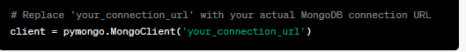
Here’s a sample:
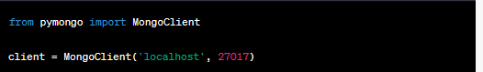

Step 4: Access Databases and Collections
Once connected, you can access a specific database and collection within that database. In this example, we'll use a database named "testdb" and a collection named "example_collection".
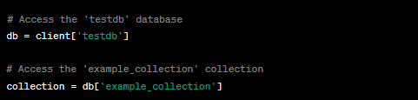

Step 5: Insert Data into the Collection
You can insert documents (data) into the collection using the insert_one() or insert_many() methods.
Here, we'll insert a single document using insert_one() method. The insert_one() method is a function provided by the pymongo library in Python, which is used to insert a single document (also referred to as a record or data item) into a MongoDB collection. It's a common operation when working with databases to add new data to a collection.
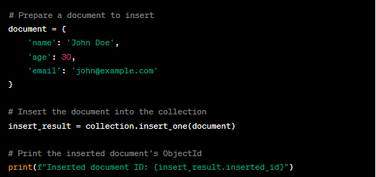

Step 6: Query Data from the Collection
You can use find() method to query data from a MongoDB collection. It allows you to retrieve documents (data items) that match a specific query criteria. The find() method returns a cursor, which is an iterable object that you can use to access the matching documents.
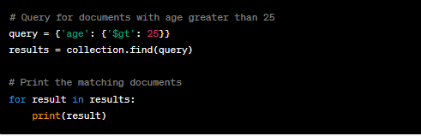

Step 7: Update Data in the Collection
To update data, use the update_one() or update_many() methods. Here, we'll update a single document using update_one() method. The update_one() method is a function provided by the pymongo library in Python, used to update a single document within a MongoDB collection. It allows you to modify specific fields or attributes of a document that matches a given query. The update_one() method is useful when you want to change specific data without affecting multiple documents.
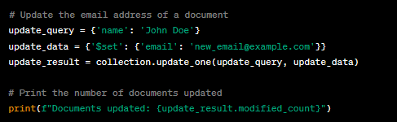

Step 8: Delete Data in the Collection
You can delete data using the delete_one() and delete_many() methods. Here, we'll delete a single document. Just like update_one(), this method allows you to remove a specific data item from the collection without affecting multiple documents.
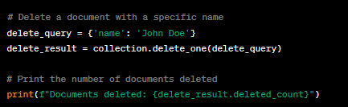

Step 9: Disconnect from MongoDB
After performing your operations, close the connection to the MongoDB server:
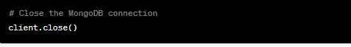

Conclusion
In the above example, we imported the pymongo module and established a connection to the MongoDB server using the MongoClient class. We accessed a specific database and collection using dictionary-style access. We inserted a document using the insert_one() method and printed the inserted document's ObjectId. We queried data using the find() method and printed the matching documents. We updated a document using the update_one() method and printed the number of modified documents. We deleted a document using the delete_one() method and printed the number of deleted documents. Finally, we closed the connection to the MongoDB server.
Remember that MongoDB provides a flexible schema, meaning different documents within the same collection can have varying structures. The pymongo library automatically handles the conversion between Python data structures and BSON (Binary JSON), which is the format used by MongoDB.
By integrating Python with MongoDB using the pymongo library, you can leverage MongoDB's flexibility and scalability to efficiently manage and manipulate data in your applications.

